Etana Disasa: Final Project

Downloading data from https://data.stackexchange.com



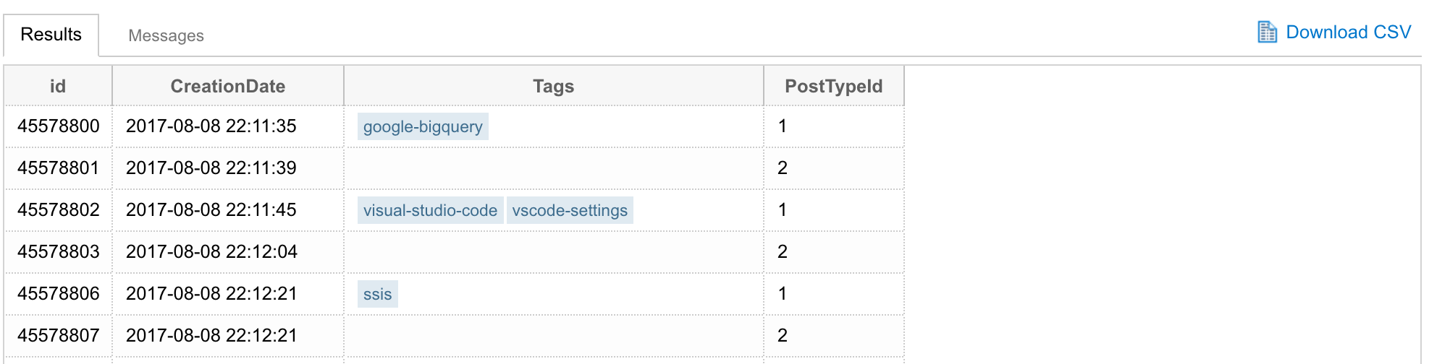

Download findspark, and pyspark



Hadoop Version

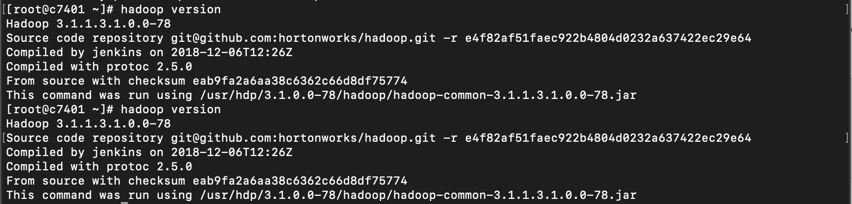

Copying the CSV file into the Hadoop DFS.

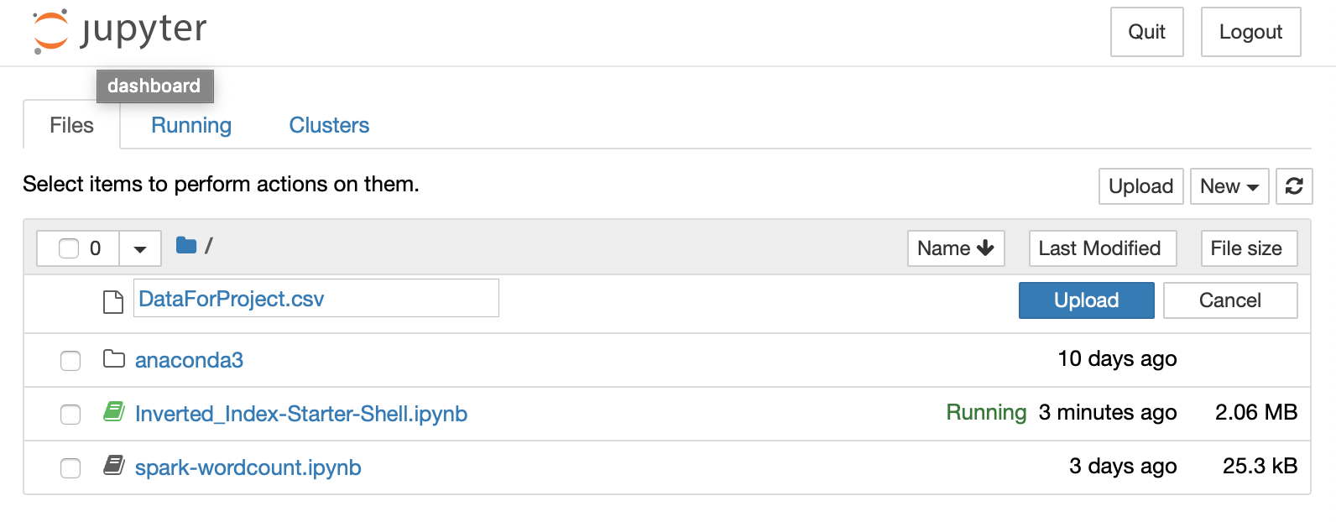

Copy CSV file into the HDFS

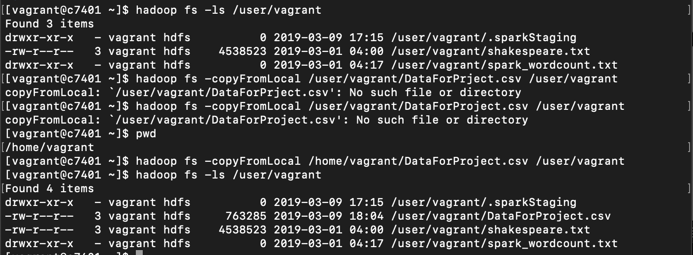

I have included each step and codes in the Jupyter File as #Comments.

Here is the snap of the final json file in the file system at the bottom “FinalProject.json”.

